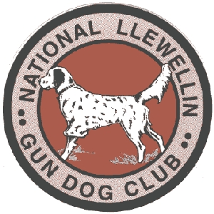
National Llewellin Gun Dog Club
Northern Llewellin Fall Field Trial
September 21th & 22nd 2013 starting at 7:30 am
Sponsored by
Three Arrows Hunting Preserve www.huntthreearrows.com

Call Name: ____________Registered Name of Dog: _____________________________
*Entries restricted to FDSB registered Llewellins
FDSB #: _________________ (please include photocopy of registration certificate)
Color: ________________ Male _____ Female ______ Date whelped: ____________
Sire: ________________________________ Dam: _____________________________________
Handler: ______________________________________

Owner: _______________________________________ Phone #: ________________________
Address: ______________________________ City: ____________ State: _____ Zip: _______
Email Address: _____________________________________________

Birds used will be Quail
_____OPEN (no age restrictions) - 30 mins ~~~ Sat & Sun $45.00 x 2 for both days __________

______DERBY (under age 2 on day one of trial season) -30mins~Sat
(& Sun if enough interest) $40.00 x 2 for both days _______

____PUPPY- (under age 1 on day of trial) - 20mins ~~~ $25.00_________

Entries close WED. Sept 18^{th,} 8:00pm

Send Entries make checks payable to: Ben Jacobsen
78589 125th Street – LeRoy, MN 55951
DON’T forget to renew your membership too www.llewellinsetterclub.com

National Llewellin Gun Dog Club
Northern Fall Trial
September 21th & 22nd 2013 starting at 7:30 am
*Entries restricted to FDSB registered Llewellin’s
Double Open Event

Sponsored by
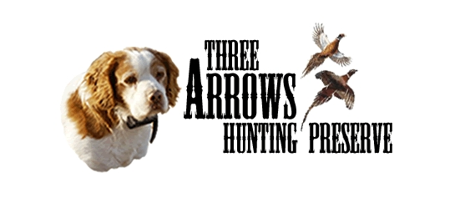
To Be Held @ Three Arrows Hunting Preserve, LeRoy, MN www.huntthreearrows.com

&


Chairman: Ben Jacobsen 507-438-3313

Lunch will be served at the trial
Also a group dinner is planned for Friday & Saturday evening

Grounds available for training on Friday call to prearrange 507-438-3313

Honorary Judges for Saturday & Sunday:
Mike Ryan
Rob Enedy

Hotels in the area:
Sweets Hotel - LeRoy, (3 miles) www.sweetshotel.com Special rates for trial people (no dogs in rooms)
Spring Valley Inn & Suites (16 miles) www.springvalleyinnsuites.com (Dogs for a small fee)
Camping:
Our yard (free) no hook ups
Deer Creek Speedway Camp Ground (13 Miles) 507-346-2342 www.deercreekspeedway.com/campground

