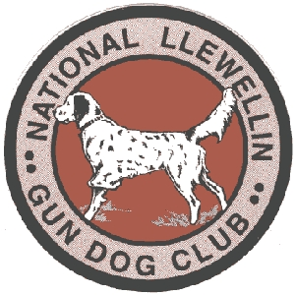
National Llewellin Gun Dog Club
December 2024 “Snowfall” Kentucky Field Trial

December 14-15, 2024
Entries restricted to FDSB registered Llewellins
Sponsored by: Sinking Fork Kennels

Chairman: Tim Powell

More details will be on the NLGDC website

***ALL MEMBERS ATTENDING ARE REQUESTED TO BRING A DOG ORIENTED ORNAMENT FOR THE SINKING FORK / NLGDC CHRISTMAS TREE ***

Held in Hopkinsville, Ky. @ Sinking Fork Field Trial Grounds located at 721 Shepherd Rd, Hopkinsville Ky 42240

***IMPORTANT***

ENTRY FORMS: Please submit checks for trial to Tim Powell no later than Dec.7,2024.
Send Entries to: Tim Powell - P.O. Box 67 Gracey, KY 42232
Telephone: (270)348-4488 or (270)719-0932 or (270)887-9964
cxpsetter@me.com
Entries close Saturday December 7 at 7:00 pm EST.


