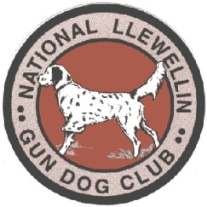

**National Llewellin Gun Dog Club**

**THE NLGDC INDIANA FALL CLASSIC**

**November 16 & 17, 2024 at the Conservation Bird Dog Club**

**3802 S. 550 W.**

**AMO, Indiana 46121**

**Sponsored by River View Kennels**

**You must be a paid member to enter your dogs. Renew your membership at** [www.llewellinsetterclub.com](http://www.llewellinsetterclub.com)

**We will have the following classes on Saturday 11/16/2024**

**Open Double/Double**

**Open A and B Fields**

**Single Derby A Field**

**Classes on Sunday 11/17/2024**

**Open Double/Double**

**Open A and B Fields**

**Single Derby A Field**

**Absolutely NO alcoholic beverages allowed on AMO Club Grounds**

**Birds used will be Quail**

**You may exercise your dogs in the field on Friday but will not be allowed to plant or work with any live birds.**

**Please contact Jon Bronnenberg at 260-358-7277 (text or call) or** [**jonbron@citznet.com**](mailto:jonbron@citznet.com) **as soon as possible and let me know if you will be able to attend.**

**We hope to see all of you there!**