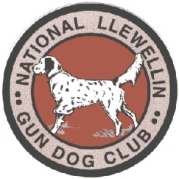

**National Llewellin Gun Dog Club**

**Hotel Accommodations Nearby For**

**THE NLGDC INDIANA FALL CLASSIC**

**November 16 & 17, 2024 at Conservation Bird Dog Club**

**3802 S. 550 W.**

**AMO, Indiana, 46121**

**Camping with electric is available onsite.**

**Bring a cot. Room above the clubhouse also available.**

1. **Quality Inn. Plainfield, IN. 317-204-4289**
2. **Comfort Inn. Plainfield IN. 317-204-3768**
3. **Clarion Pointe. Plainfield, IN. 317-837-8888**
4. **Hampton Inn. Plainfield, IN. 317-839-9993**
5. **Baymont. Plainfield, IN. 317-837-9000**
6. **Days Inn. Plainfield, IN. 317-839-5000**

**There are numerous other places in the area to stay as well.**

**Please contact Jon Bronnenberg at 260-358-7277 (text or call) or** [**jonbron@citznet.com**](mailto:jonbron@citznet.com) **as soon as possible and let me know if you will be able to attend.**

**We hope everyone can make it!**